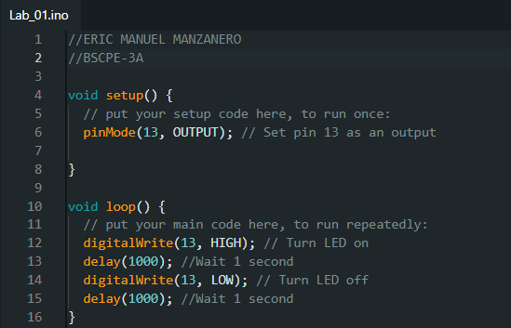
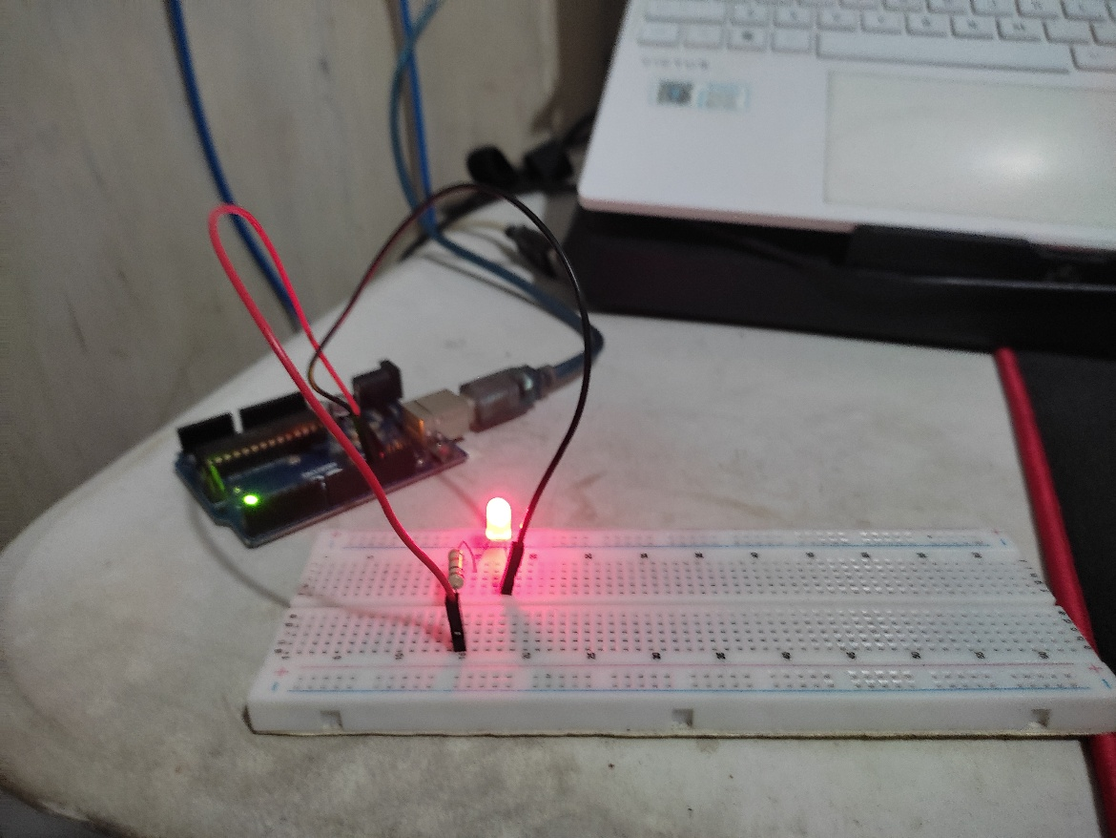
Figure 2: Arduino Sketch
Figure 1: Hardware Set-up

